**Associate an IPv6 CIDR block with existing VPC and subnets and Ec2 instances.**

**Associate an IPv6 CIDR block with a VPC: -**

1. Open the Amazon VPC console.
2. In the VPC dashboard, choose Your VPCs.
3. Select your VPC.
4. Choose Actions, Edit CIDRs and then choose Add new IPv6 CIDR.
5. Select one of the following options, and then choose Select CIDR
6. Amazon-provided IPv6 CIDR block
7. Choose **Close**.

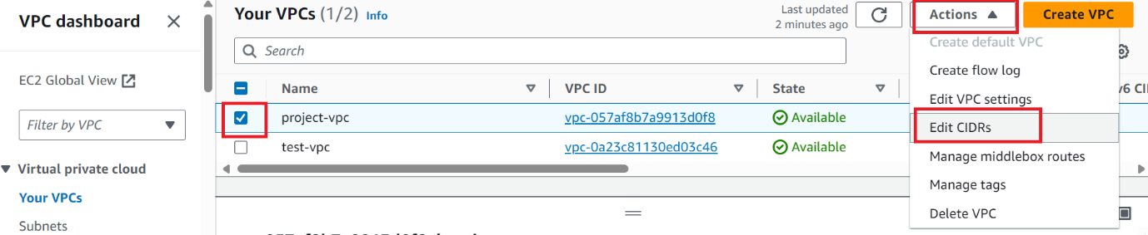

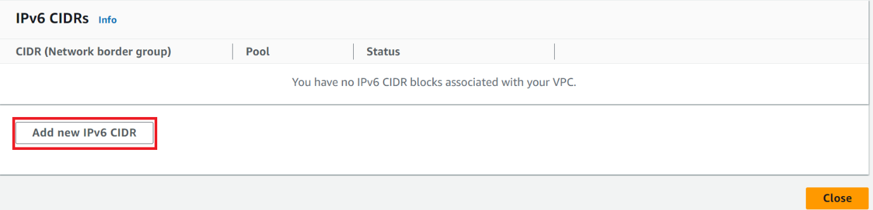

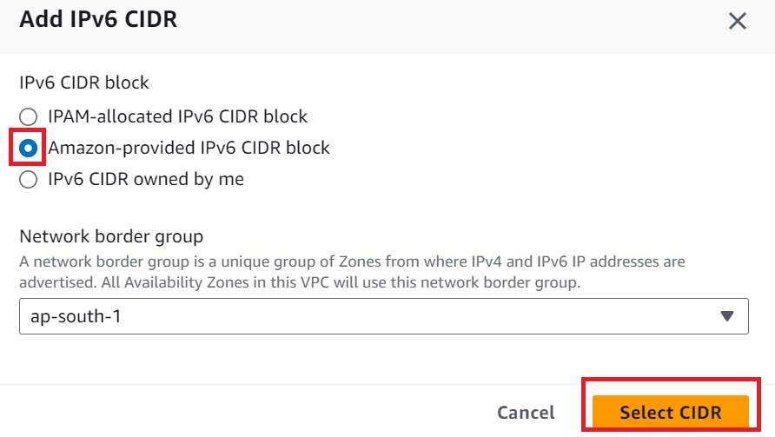

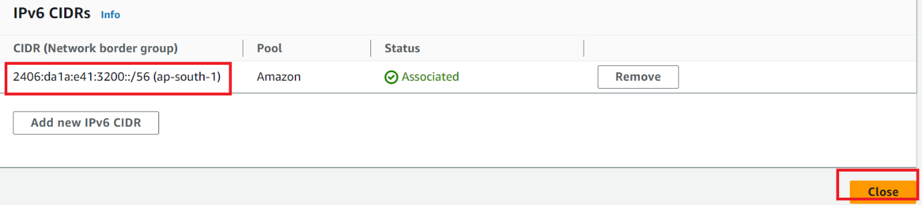

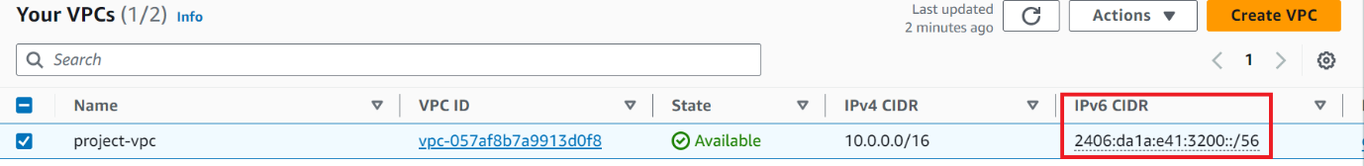

**To associate an IPv6 CIDR block with a subnet: -**

1. In the VPC dashboard, choose **Subnets**.
2. Select a subnet.
3. Choose **Actions**, **Edit IPv6 CIDRs** and then choose **Add IPv6 CIDR**.
4. Edit the CIDR block as needed.
5. Choose **Save**.
6. Repeat this procedure for any other subnets in your VPC.

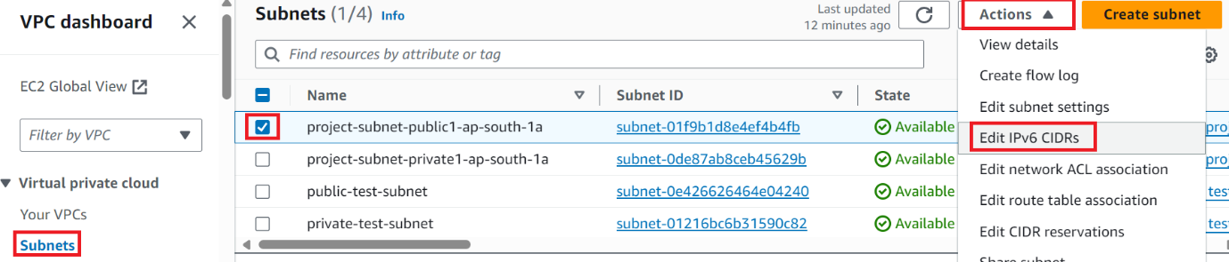

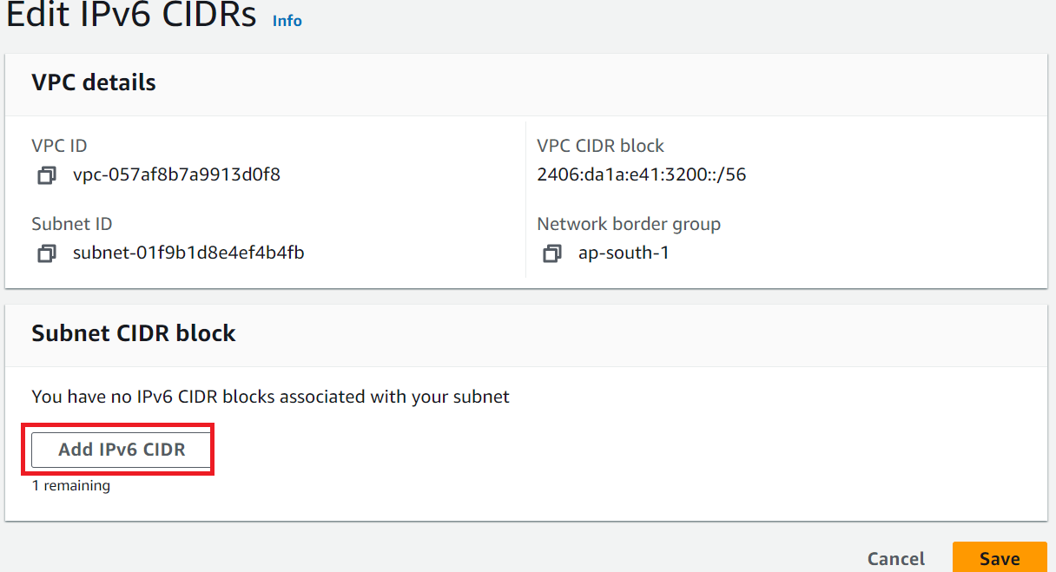

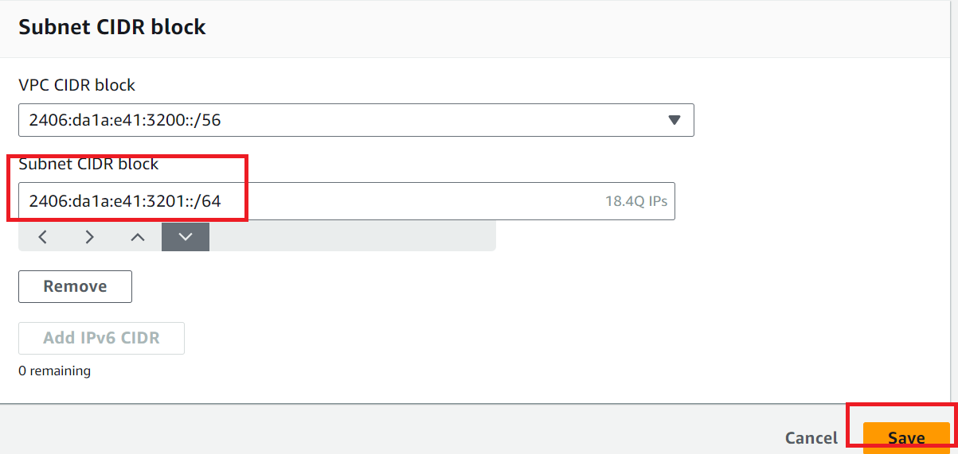

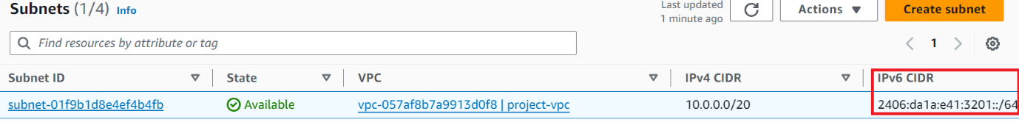

**To update the route table for a public subnet: -**

1. In the VPC dashboard, Select the route table. On the **Routes** tab, select your public route and choose **Edit routes**.
2. Choose **Add route**. Choose ::/0 for **Destination**. Choose the ID of the internet gateway for **Target**.
3. Choose **Save changes**.

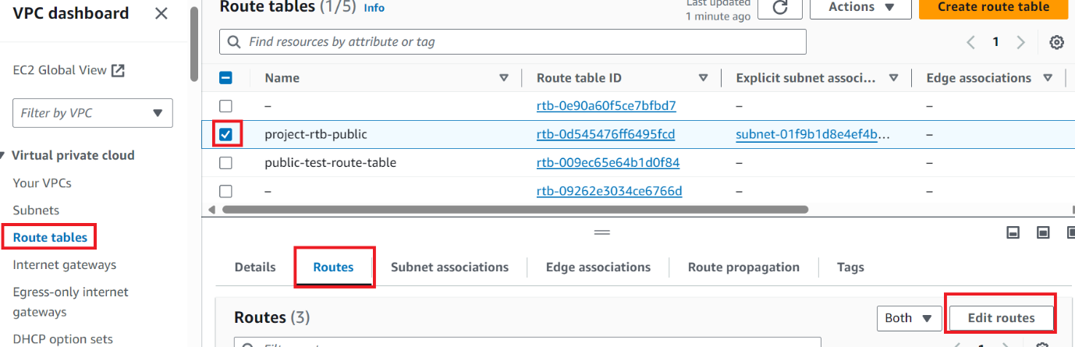

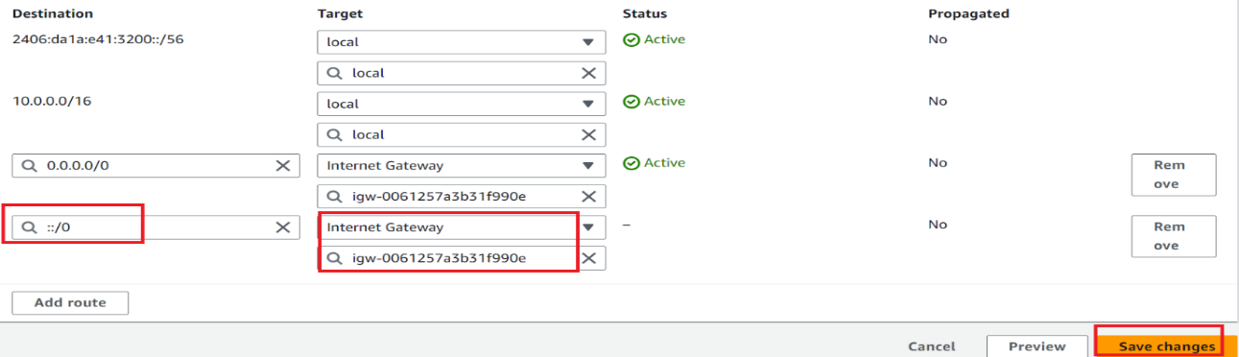

**To create Egress only internet gateway: -**

1. In the VPC dashboard, choose **Egress-only internet gateways**. Choose **Create egress only internet gateway**. Choose your VPC from **VPC**, and then choose **Create egress only internet gateway**.

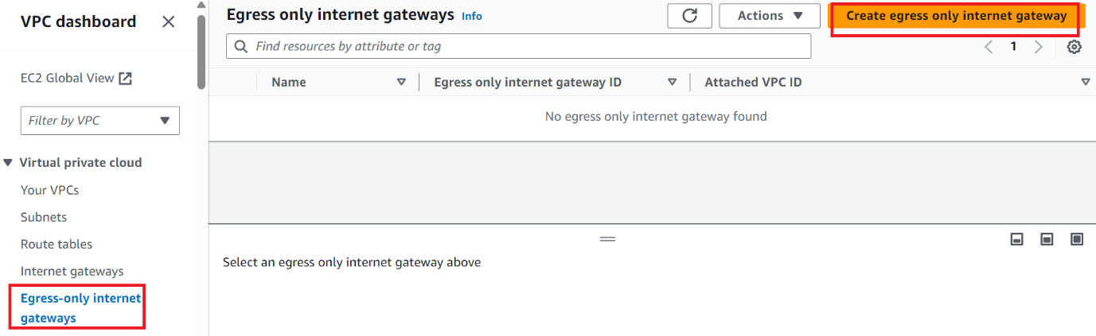

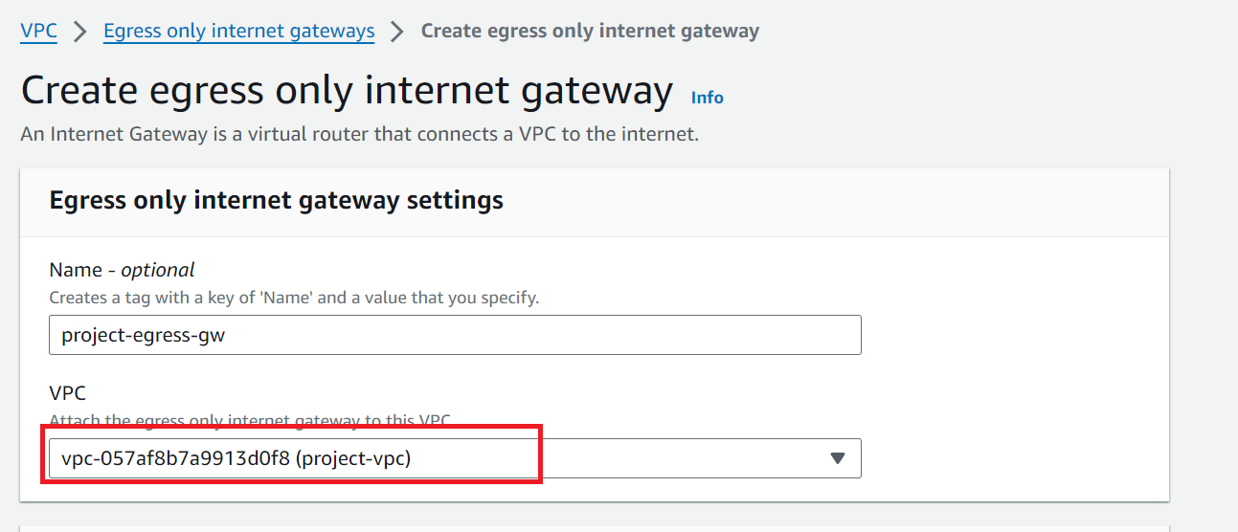

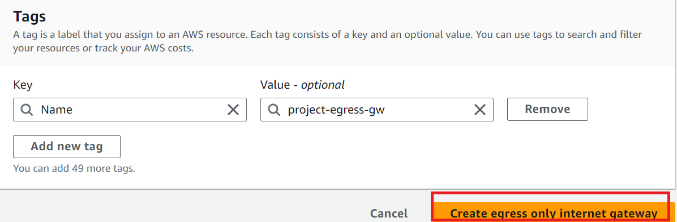

**To update the route table for a private subnet: -**

1. In the VPC dashboard, Select the route table. On the **Routes** tab, select your private route and choose **Edit routes**.
2. Choose **Add route**. Choose ::/0 for **Destination**. Choose the ID of the egress-only internet gateway for **Target**.
3. Choose **Save changes**.

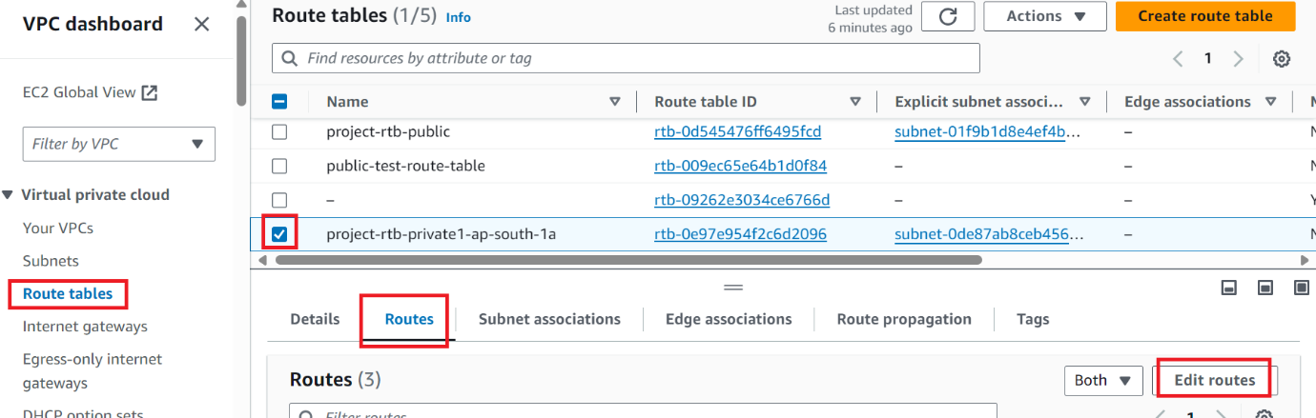

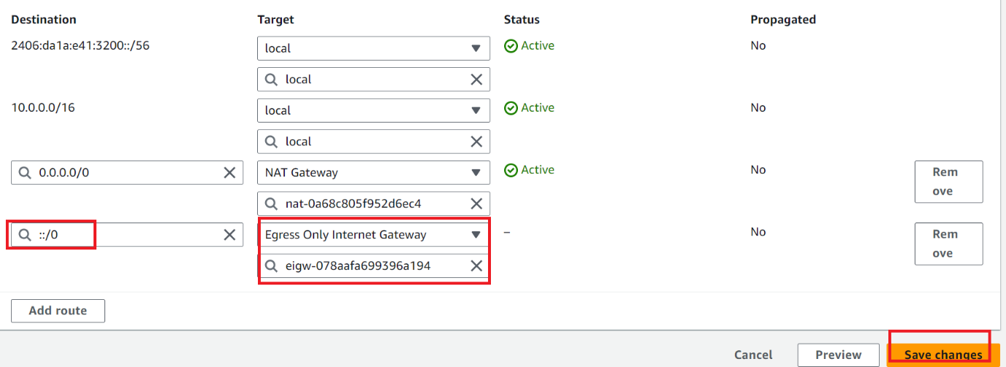

**Associate ipv6 to the ec2: -**

1. Open the Amazon EC2 console.
2. In the ec2 dashboard, choose your existing **Instances**.
3. Choose **Actions**, **Networking** and then choose **Manage ip address**.
4. Select etho and click on assign new ip address
5. Choose **Save**. And confirm the ip address update.

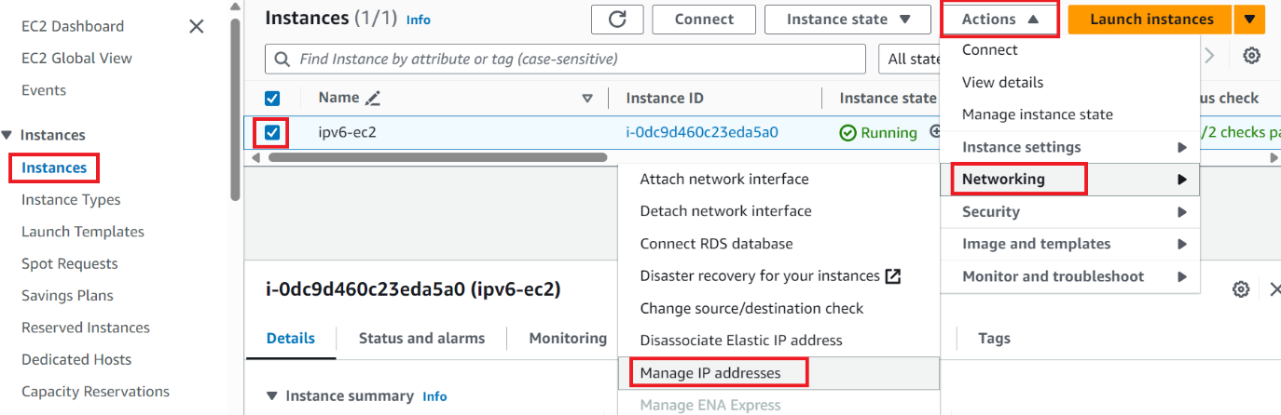

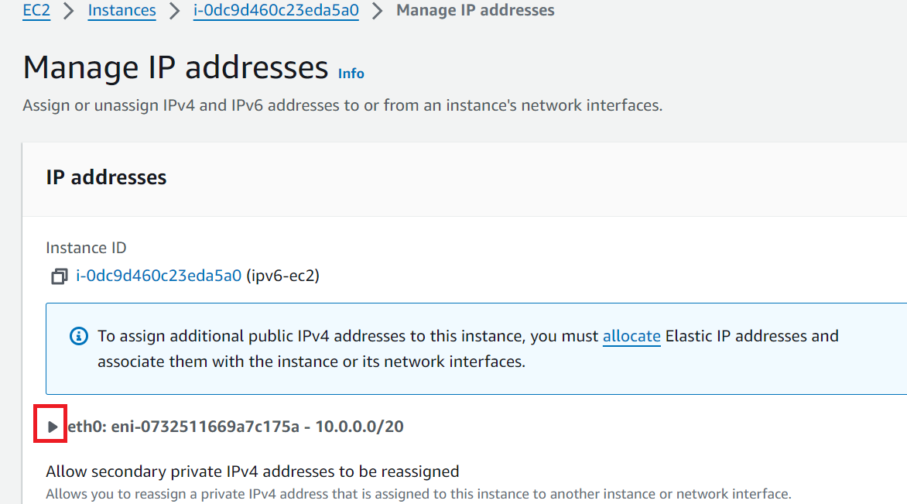

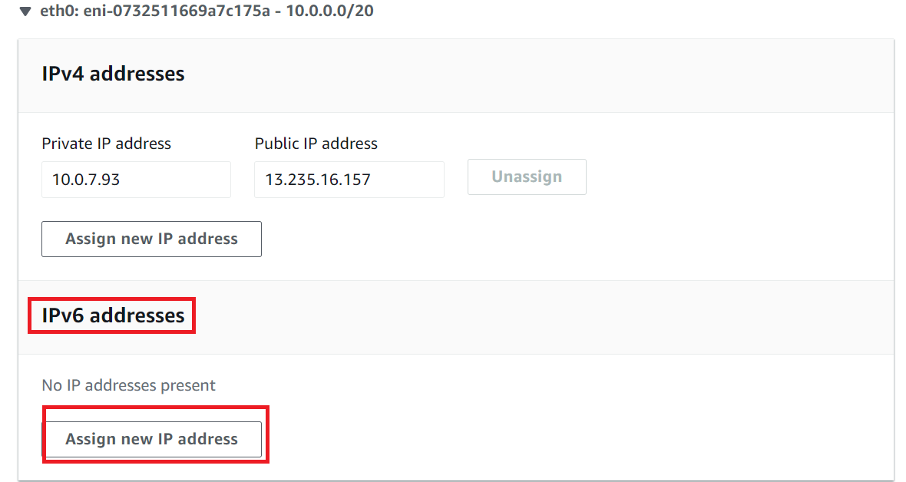

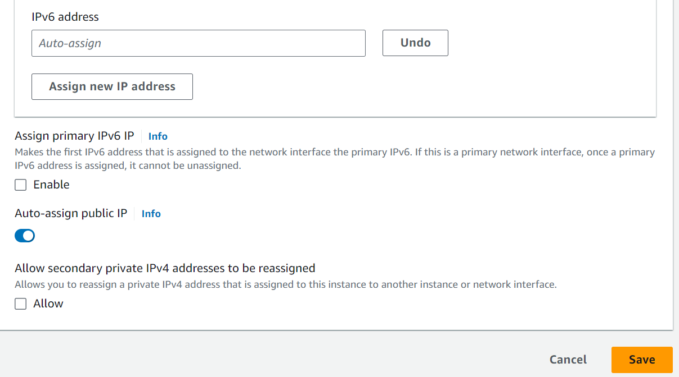

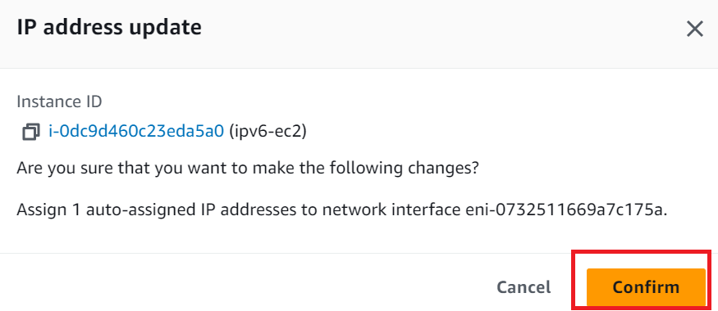

**Connecting to the ec2 instance through the VPC endpoint: -**

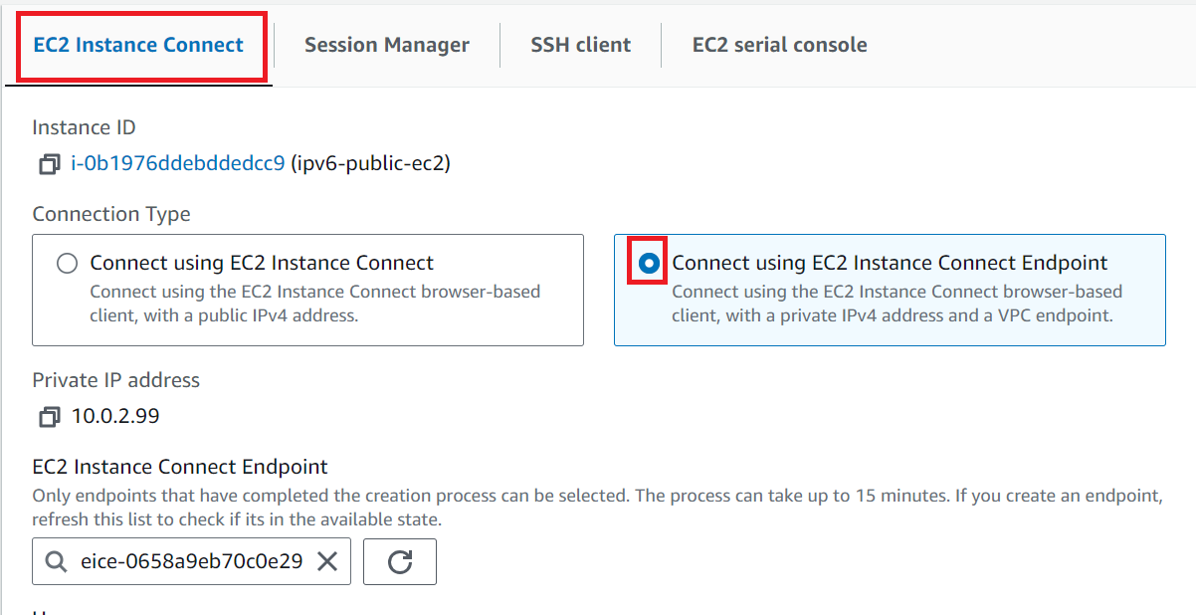

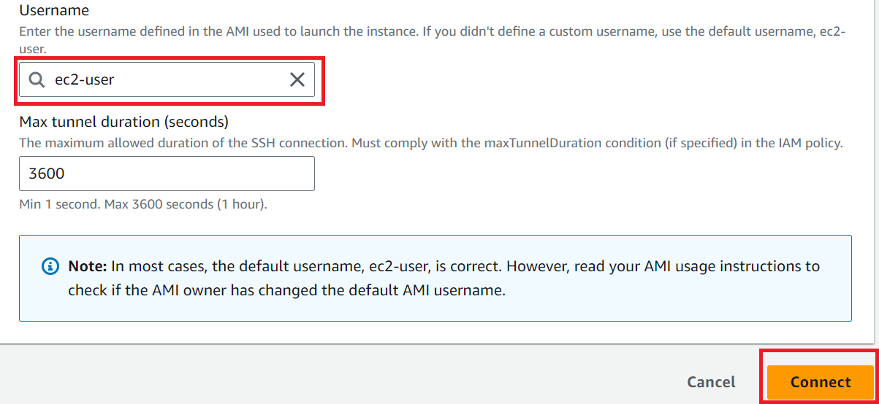

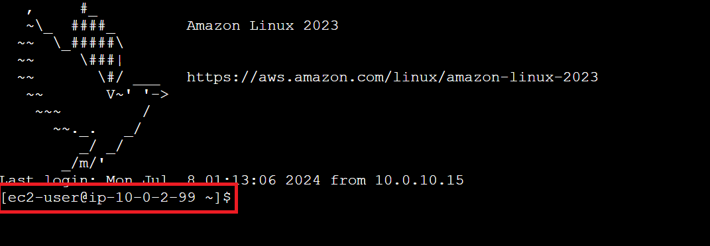

**Public instance connecting to the Private instance: -**

* Go the root user execute the “**sudo su**” command.
* Create pem key file in this ec2 instance “vi keyname”
* Give right permissions to the pem key file “chmod 400 keyname”
* Using below ssh command connect to the private instance.

ssh -i “pem keyname” ubuntu@2406:da1a:e41:3202:96a0:289c:e6d2:a2a0

ssh -i ce-dev-key.pem ubuntu@ 10.0.136.197

